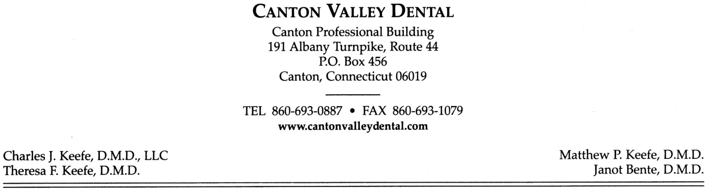
Informed Consent for Dental Treatment
X-rays:
Proposed treatment: taking of intraoral and extraoral radiographs.
Benefits of treatment: taking x-rays enables us to view dental cavities, abnormalities, development and eruption of teeth. They are also necessary for proper diagnosis and evaluation purposes.
Alternatives of treatment: none; limited visual examination
Common Risks: radiation exposure to soft and hard tissues.
Consequences of not performing the treatment: missed diagnosis.
Cleaning:
Proposed treatment: involves thorough cleaning of teeth to help heal inflammed or infected gum tissue. It involves removal of soft plaque build-up and harder calculus deposits above and below the gum line.
Benefits of treatment: healthy oral environment; also, reduction/elimination of bleeding, odor and periodontal disease.
Alternatives of treatment: referrals for periodontal (gum) surgery according to the severity of condition.
Common risks: bleeding, soreness, swelling, infection of tissue, hot and cold sensitivity, stiff or sore jaw joint.
Consequences of not performing the treatment: discontinued or interrupted treatment could result into further inflammation and infection of gum tissues, lead to more tooth decay, and deterioration of surrounding bone structure which could lead to tooth loss.
Anesthetic:
Proposed treatment: injection of anesthetic to surrounding oral tissues.
Benefits of treatment: numbness of tissue and muscle surrounding area of treatment to eliminate pain sensation.
Alternatives to treatment: dental restorations performed with no anesthetic resulting in severe sensitivity and pain.
Common risks: allergic reaction, irritation to nerve tissue, stiff or sore jaw joint, swelling of tissue, bruising and may cause temporary or permanent paralysis.
Consequences of not performing the treatment: severe pain and sensitivity.
Fillings:
Proposed treatment: to remove dental caries and replace with filling material to regain proper tooth anatomy.
Benefits of treatment: restore tooth structure for proper function.
Alternatives of treatment: temporary filling, crown, extraction.
Common risks: allergic to filling material, tooth sensitivity, filling may come out.
Consequences of not performing the treatment: further spread of decay, requiring root canal treatment or severe destruction resulting in tooth loss.
Amalgam (Silver) VS. Composite (Tooth Color):
Amalgam advantages include; Strong, can stand up to biting force, cost effective, resistance to further decay is high, risk of sensitivity is lower, long lasting. Disadvantages include; less attractive than tooth color alternatives, placement may require removal of healthy tooth structure, corrosion may darken the appearance.
Composite advantages include; Color and shade can be matched to the teeth, permits preservation of as much tooth structure as possible, frequency of repair is low. Disadvantages include; Can break or wear out quicker than silver, more expensive, may leak over time requiring replacement, can create sensitivity to cold.
Root Canal Treatment:
Proposed treatment: to remove infected pulp tissue and replace with root canal filling material.
Benefits of treatment: eliminate pain, infection, swelling and further destruction of tooth structure.
Alternatives of treatment: extraction.
Common risks: recurrence of symptoms, breakdown of tooth structure.
Consequences of not performing the treatment: increase in severity of pain, swelling, infection, and possible hospitalization and rare instances death.
Crown and bridge:
Proposed treatment: to strengthen a tooth damaged by decay or previous restoration, and protect a tooth that has had root canal treatment. Improve the biting surface, appearance of damaged, discolored, poorly spaced and/or missing teeth.
Benefits of treatment: to restore or improve the appearance and strength of teeth.
Alternatives of treatment: extraction or Orthodontic treatment (only in proper spacing, not damaged teeth).
Common risks: irritation to surrounding tissue, inflammation, irritation to nerve tissue, stiff or sore jaw joint, sensitivity to hot and cold, also possible root canal treatment.
Consequences of not performing the treatment: further destruction, nerve exposure, loss of tooth function, root canal treatment.
Tooth Extraction:
Proposed treatment: complete removal of a tooth from the mouth
Benefits of treatment: to relieve symptoms and/or permit further planned treatment
Alternatives of treatment: depending on individual treatment needs: root canal treatment, periodontal therapy, crown or filling, no treatment
Common Risks: as with any surgical procedure; discomfort, bleeding, swelling, possible damage to adjacent teeth and/or soft tissue, transient numbness of the jaw
Consequences of not performing the treatment: increase in severity of pain, swelling, infection, and possible hospitalization and rare instances death.
Dental Implants:
Proposed treatment: replacement of a missing tooth with a titanium implant placed into the jaw. Dental implants are a 2 phase procedure; phase 1 is the surgical placement and subsequent exposure performed by an oral surgeon. Phase 2 is the prosthetic replacement performed at this office
Benefits of treatment: functional tooth replacement that provides support for artificial teeth and/or crown and bridge
Alternatives of treatment: removable dentures, dental bridges, no replacement
Common Risks: as with any surgical procedure; discomfort, bleeding, swelling, possible damage to adjacent teeth and/or soft tissue, transient numbness of the jaw
Consequences of not performing the treatment: movement of adjacent and opposing teeth, loss of bone level, difficulty chewing with decreased dentition

I have read and understood the entire information on this consent form, which includes x-rays, cleaning, anesthetic, fillings, root canal treatment, crown and bridge, tooth extraction and dental implants. All my questions were answered to my full understanding and satisfaction.
Signature of patient, parent, or legal guardian:
_____________________________________________________________________________________

Date:

